**Project Documentation**

**Module 1: Web-based flight simulator application**

**Tab 1: Objective**

Fly your plane in a 3D world, complete exciting missions, and explore the skies. Take off, land, and master cool flying tricks.

**Tab 2: Science**

This project integrates various scientific and engineering principles.

1. **Lift Equation (Aerodynamics)**

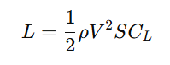

* L = Lift force
* ρ = Air density
* V = Velocity of the aircraft
* S = Wing area
* CL = Lift coefficient

1. **Drag Equation**

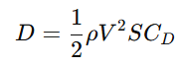

* D = Drag force
* CD = Drag coefficient

1. **Angular Motion (Aircraft Rotation)**



* T = Torque
* I = Moment of inertia
* α = Angular acceleration

**4. Thrust Equation**



* T = Thrust
* m = Mass of the aircraft
* a = Acceleration

1. **Newton’s Second Law (Motion of the Aircraft)**



* F = Net force acting on the aircraft
* a = Acceleration

1. **Bernoulli’s Principle (Pressure Difference for Lift)**



* P1, P2 = Pressure at different points
*  = Air velocity at different points

**Tab 3: Significance**

* **Educational Resource**: Provides interactive simulations and real-world applications for learning aerospace concepts.
* **Immersive Exploration**: Allows users to explore diverse landscapes, weather conditions, and flight challenges.
* **Realistic Aviation Experience**: Simulates real-world flight dynamics, including take off, landing, and manoeuvring.
* **Technological Advancement**: Utilizes 3D graphics, physics engines, and AI to create lifelike flight experiences.
* **Understanding Aircraft Systems**: Provides detailed insights into engine management, instrument panels, autopilot systems, and emergency procedures.
* **Multi-View & Camera Angles**: Allows players to switch between cockpit, third-person, and instrument panel views for a dynamic experience.

**Tab 4: Description**

**Features:**

* Browser-based interactive flight simulator.
* Uses open-source data and point mass models for realism.
* Supports multiple input methods (keyboard, joystick, and touch).
* Simulates flight physics with customizable parameters.
* Immersive pilot view experience
* Dynamic weather and time system
* **Usage instructions**
* **A: To increase speed**
* **D: To decrease speed**
* **Arrow up: To Land**
* **Arrow down: To Take-off**
* **Arrow left: To move Left**
* **Arrow right: To move Right**
* **R: Reset**
* **c: Pilot view**
* **b: bird view**

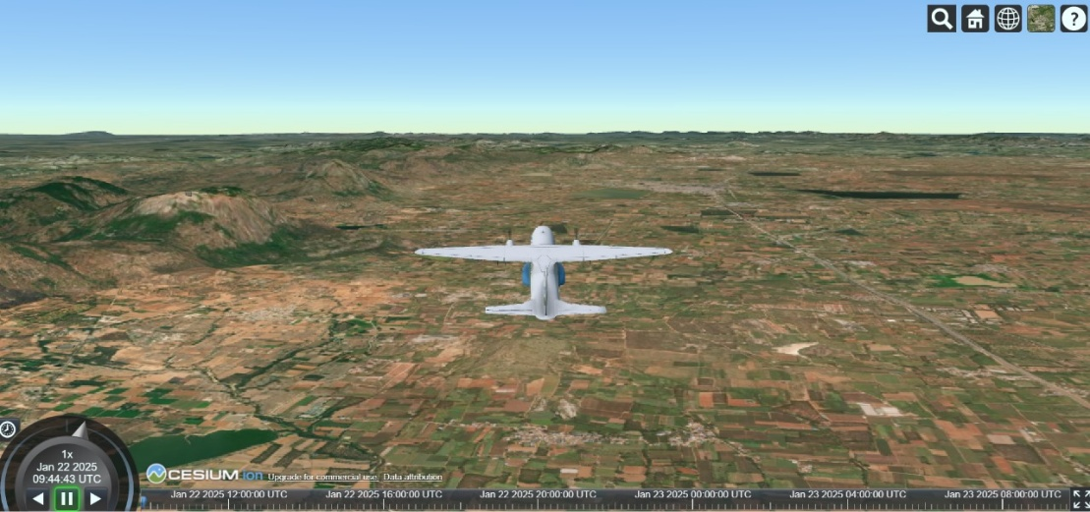

Fig: 1

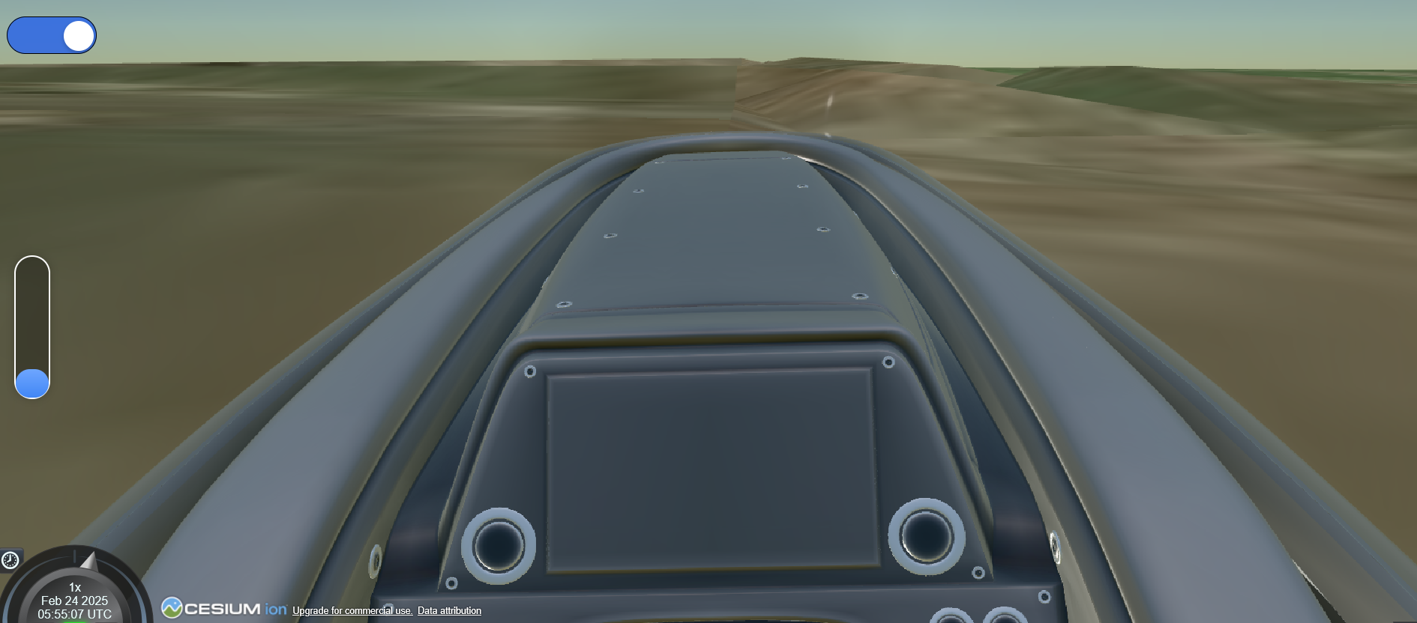

Fig: 2

**Tab 5: Quiz**

This section consists of multiple-choice questions to test theoretical knowledge and analytical exercises to enhance understanding.

**Multiple-Choice Questions:**

1. **What is Newton’s second law?**
   * A) F=ma
   * B) E=mc2
   * C) P=IV
   * D) V=IR
2. **F = ma**
3. **What factors influence the lift equation?**
   * A) Air density, velocity, lift coefficient, and wing area
   * B) Gravity and thrust
   * C) Mass and acceleration
   * D) Magnetic field strength

**A) Air density, velocity, lift coefficient, and wing area**

1. **What is the primary function of image registration?**
   * A) Aligning multiple images for analysis
   * B) Enhancing image colors
   * C) Compressing images
   * D) Converting images into text

**A) Aligning multiple images for analysis**

1. **What does a perspective projection matrix achieve?**
   * A) Adjusts image brightness
   * B) Transforms 3D scenes onto a 2D plane
   * C) Converts images into grayscale
   * D) Increases pixel density

**B) Transforms 3D scenes onto a 2D plane**

1. **Which force counteracts gravity in flight?**
   * A) Thrust
   * B) Drag
   * C) Lift
   * D) Weight

**C) Lift**

1. **What type of control surface helps an aircraft roll?**
   * A) Rudder
   * B) Aileron
   * C) Elevator
   * D) Flaps

**B) Aileron**

1. **What is a key application of scene generation in flight simulation?**
   * A) Weather forecasting
   * B) Visualizing realistic flight environments
   * C) Enhancing fuel efficiency
   * D) Encrypting flight data

**B) Visualizing realistic flight environments**

1. **What happens when a camera's focal length increases?**
   * A) Widens the field of view
   * B) Narrows the field of view
   * C) Increases image brightness
   * D) Reduces image resolution

**B) Narrows the field of view**

1. **What is an essential requirement for effective image registration?**
   * A) Random noise in images
   * B) Clear control points
   * C) High pixelation
   * D) Equal file size of images

**B) Clear control points**

1. **What does six degrees of freedom (6DOF) in flight dynamics include?**
   * A) Pitch, yaw, roll, surge, sway, heave
   * B) Acceleration, velocity, momentum, thrust, drag, lift
   * C) Up, down, left, right, forward, backward
   * D) Wing span, altitude, weight, speed, temperature, humidity

**A) Pitch, yaw, roll, surge, sway, heave**